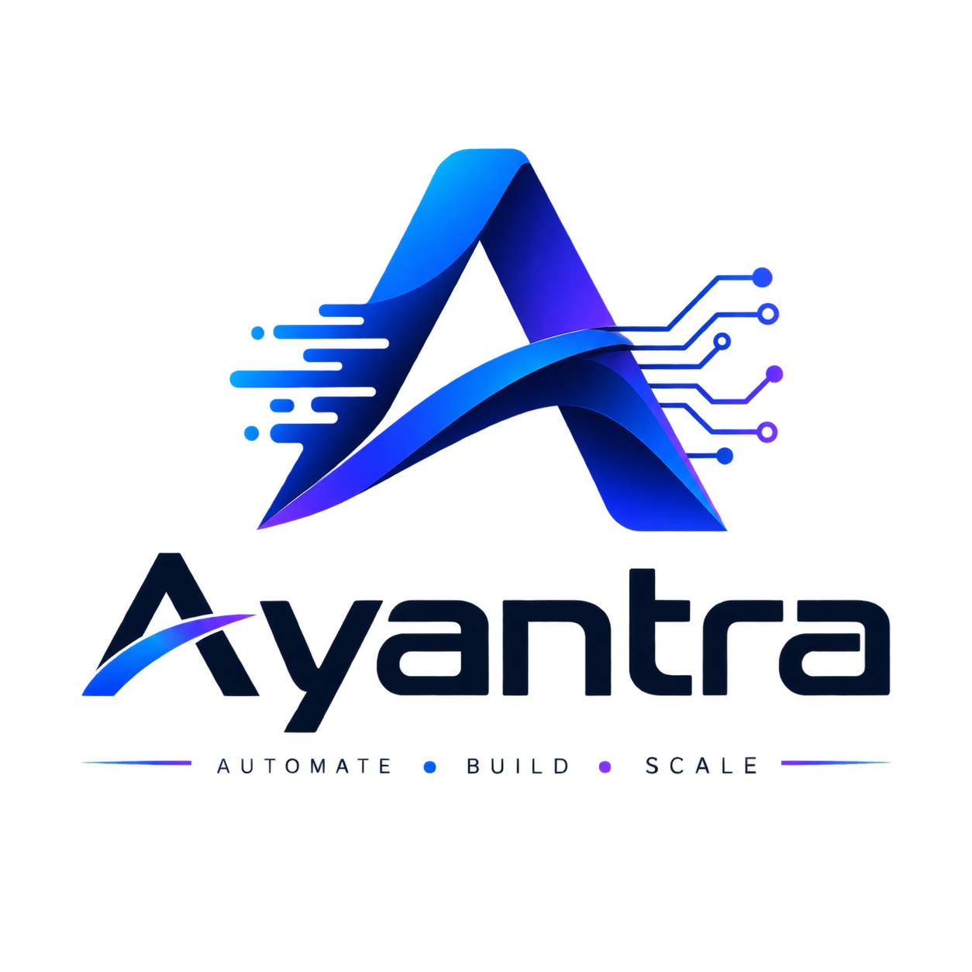
AYANTRA

Websites that build to turn visitors into customers

Quotation Summary
Quotation No #: | AY-QT-2026-001
Quotation Date: | August 22, 2026
Valid Till Date: | September 06, 2026

Party Details
Quotation From | Quotation For
Ayantra Technologies  Pune, Maharashtra, India - 411011  Email: contact@ayantratechnologies.com  Phone: +91 84595-50071 | [Client Name / Business Name]  [Client Address Line]  Email: [client@example.com]  Phone: [+91 XXXXX-XXXXX]  Place of Supply: Maharashtra (27) | Country: India

Itemized Rate Card
Item & Description | GST Rate | Qty | Rate (₹) | Amount (₹) | Total (₹)
1. Ayantra Starter Landing Site  Single-page responsive layout (mobile/desktop), hero section, services overview, subtle UI animations, foundational on-page SEO, standard deployment. | 0% | 1 | 5,500 .00 | 5,500.00 | 5,500.00
2. Contact & Lead Integration Setup  Interactive lead capture form, direct WhatsApp CTA button, company contact details, map embed, and automated mail routing. | 0% | 1 | 2,000.00 | 2,000.00 | 2,000.00

Financial Breakdown
Total in Words: | SEVEN THOUSAND FIVE HUNDRED RUPEES ONLY
Subtotal: | ₹7,500.00
CGST (0%): | ₹0.00
SGST (0%): | ₹0.00
Total (INR): | ₹7,500.00


Terms & Conditions

- Payment Terms: 50% advance due upon project kickoff; remaining 50% due upon final staging demo approval prior to live domain handover.
- Scope & Revisions: Includes up to 2–3 structured revision rounds within the agreed project scope. Out-of-scope feature requests are billed separately at ₹1,000/hr.
- Ownership Transfer: Full rights to the website design, code repository, and digital assets transfer to the client upon receipt of complete payment.
- Client Content Provision: The client is responsible for supplying legal and accurate content (logos, copy, branding assets). Ayantra Technologies is not liable for copyright issues arising from client-provided materials.
- Third-Party Infrastructure: Domain name registration, cloud hosting, and third-party API/CRM services are direct client expenses and are not included in the design/development fee.
- Post-Launch Maintenance: Retainer-based updates, bug fixes, and ongoing maintenance are available at an optional ₹2,000/month.

"Looking forward to creating a professional and impactful online presence for your brand."
This is an electronically generated document; no signature is required.

